Content

## Amendment History----------------------------------------------------------3

## Purpose of the Project-------------------------------------------------------3

## Background-------------------------------------------------------3

## Aim-----------------------------------------------------------------3

## Objectives-----------------------------------------------------------------3

## Viewpoints----------------------------------------------------------------------3

## Indirect-----------------------------------------------------------------------4

## Interactor--------------------------------------------------------------------4

## Domain-----------------------------------------------------------------------4

## Mandated Constraints--------------------------------------------------------5

## Solution Constraints-------------------------------------------------------5

## Implementation Environment-------------------------------------------5

## Partner Applications-------------------------------------------------------5

## Commercial off the Shelf Packages------------------------------------5

## Anticipated Workplace Environment----------------------------------5

## Timescale---------------------------------------------------------------------5

## Financial Budget------------------------------------------------------------5

## Facts and Assumptions-------------------------------------------------------6

## External Factors-------------------------------------------------------------6

## Assumptions-----------------------------------------------------------------6

## Scope of the Work-------------------------------------------------------------6

## Scope of the Project-------------------------------------------------------6

## Scope of the Product------------------------------------------------------6

## Requirements-------------------------------------------------------------------7

## New Problems-----------------------------------------------------------------11

## Tasks-----------------------------------------------------------------------------12

## Steps to Deliver the System---------------------------------------------12

## Development Process----------------------------------------------------12

## Development Phases-----------------------------------------------------12

## Risk Assessment--------------------------------------------------------------12

## Cost Assessment-------------------------------------------------------------13

## User Documentation--------------------------------------------------------13

## References---------------------------------------------------------------------14

1. Amendment History

|  |  |  |  |
| --- | --- | --- | --- |
| **Version** | **Author** | **Date** | **Description** |
| 1 | Neil Rafferty | 14/11/2016 | Original Version |

2. Purpose of the Product

**2a. Background:**

Email messaging connects over 2.5 billion people world-wide *(Radicati Group Inc., 2015)* and still continues to be the leading method of business communication today *(Radicati Group Inc., 2016)*. However, after continual use an email address will eventually fall into unwanted hands. Third parties who obtain our email addresses can spam us with marketing emails, they can spam us with dangerous phishing and malware attacks, they can build online profiles about us (sharing and selling our information) and they may even have the ability to hack into our accounts.

This project will attempt to address the issue through the development of a new type of email service. The concept behind the service is that it will manage a large amount of email addresses for each user, one per contact. This way the user will have the ability to delete unwanted contacts permanently and identify where third party spammers retrieved their contact information. In addition to this, the service has the potential to increase user privacy and security online. This is because the user would disclose a private username for authentication rather than a public email address and only the domain (which would potentially be utilised by multiple people) would link a users’ varied addresses.

**2b. Aim:**

To create an innovative, reliable, secure and user-friendly client/server email service that gives users more control over their contact information than conventional email. This through the use of managing multiple email addresses.

**2c. Objectives:**

1. Create a basic client/server email service.
2. Alter the service to allow users to manage multiple addresses.
3. Add functionality to quickly generate email addresses and link them to a given contact.
4. Allow users to report contacts on a public board for a range of offences.
5. Add more common email features.

3. Viewpoints

The following diagram (figure 1) outlines the relative stakeholders, systems and standards for this project.

*Figure 1: Viewpoint Hierarchy Diagram.*

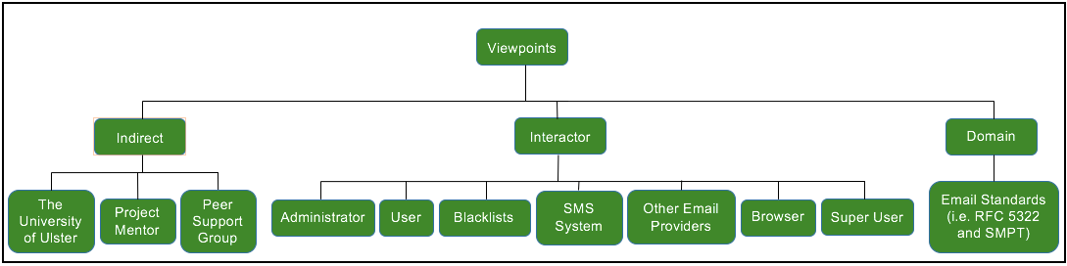

**3a. Indirect:**

The University of Ulster – As this us a university project, the university may have some influence over the direction and outcome.

Peer Support Group - Will offer support and guidance.

Project Mentor – The project mentor, Dr. Ian McChesney, will continue to offer guidance throughout the duration of the project.

**3b. Interactor:**

1. Administrator – This person will be responsible for managing User and Super User accounts.
2. Super User - This person will be responsible for managing User accounts.
3. User – A person who uses the application for communicative purpose.
4. Blacklists – Online lists of malicious emailers.
5. SMS System – This may be used for account recovery.
6. Other Email Providers – Other email providers that the system will communicate with.
7. Browser – Some browser extension functionality may be added for a better user experience.

**3c. Domain:**

1. Email Standards – Basic email standard need to be adhered too.

4. Mandate Constraints

**4a. Solution Constraints:**

1. The product must be a web application.
2. The application must management multiple email addresses.

**4b. Implementation Environment:**

1. The product will be expected to work on multiple platforms (including desktop and mobile devices)
2. The application will be hosted online.

**4c. Partner Applications:**

1. This application will send and receive correspondents to other email providers (as mentioned in 3b.3).
2. An anti-virus will be needed to scan emails for threats.

**4d. Commercial off the Shelf Packages:**

Open source resources and services should be investigated during sprint planning to reduce the project workload. This should be investigated for a:

Spam Filter.

Email Server.

Email Client.

Appointment System.

**4e. Anticipated Workplace Environment:**

1. The majority of development will be done from home on a mac.
2. Meetings will be held with the project mentor and peer support group on the university grounds.
3. Relevant academic materials will be studied in the library and online.

**4f. Deadlines:**

1. There will be a project presentation on the 12th of December 2017.
2. There will be a project showcase in week 5 of semester 2.
3. The absolute deadline for this project is in week 11 of semester 2 which will be in April 2017.

**4g. Finance:**

There is no budget for this project. However, if a cost does arise it may be paid for by the student or a request for funds can be made to the university.

5. Naming Conventions and Definitions

**5a Point of Contact:**

In relation to this project, a point of contact is a line of communication that is created when an email address is disclosed to another party.

**5b Maximum Email Size:**

This value is initially being set to a 10Mb as that is a competitive size. However, stable this could be improved if justified by testing.

6. Facts and Assumptions

**6a. External Factors:**

*no relevant external factors were found.*

**6b. Assumptions:**

1. Email communication will remain to be a popular form of communication.
2. Users interest in reducing spam and protecting their points of contact.

7. Scope of the System

**7a. Context of the System:**

Figure 2 had been used to illustrate the flow of information between the system and its interactors from **3b.**

*Figure 2: System Context Diagram.*

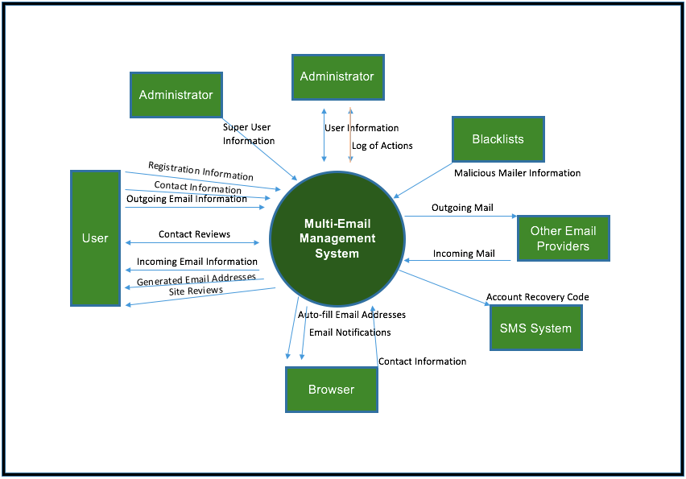

**7b. System Components:**

1. Email Server – The email server will send, receive and store user messages.
2. Email Client – The email client will retrieve emails from the server and present them to the user. It will send notifications to the user and provide functionality for the user to send messages also (through use of the email server).
3. Website – The website will host the email client and possibly a calendar too. It will provide register and log in capabilities as well as a download like for the Browser Extension.
4. Browser Extension – May be used to auto fill email addresses, store contact details and warn of reported websites.
5. Calendar – A calendar could be added to help users manage appointments.

8. Requirements Development

**8a. Requirements Gathering Processes:**

The requirements for this project have been gathered through:

1. Using common knowledge of email services.
2. Referring to previous email requirement documentation (Office of Information Technology, 2007).
3. Focused discussions (with the project peer group and mentor).
4. Questionnaires.
5. Brainstorming sessions.

**8b. Requirement Overview:**

Below is a high-level overview of the requirements. This overview briefly outlines the requirements by category.

1. Functional Requirements – Many of these have been illustrated in Figure 3 as use cases. These requirements have been divided up into different features and documented using a use case template. The features are as follows:
   1. Account – This feature is responsible for managing user accounts. This includes registering, logging in/out, changing passwords and account recovery.
   2. Messaging – The messaging feature contains requirements relating to email messaging such as sending/receiving/deleting mail, sending/saving/deleting drafts and searching the inbox.
   3. Contact – This feature contains the contact management requirements that make this email system unique. Requirements in this section include generating new email addresses/contacts, deleting/unfollowing/following contacts, editing contact names, flagging contacts for a range of offences and searching through contacts.
   4. Mail Rules – There is currently only one mailing rule requirement. Combined with the contact management requirements the ability to set incoming mailing rules has the potential to be extremely beneficial to users.
   5. Calendar – This feature contains requirements such as adding, removing and editing appointments in the calendar view.
   6. Admin – The admin feature manages extra administration tool functionalities for the administrator super users.
2. Non-Functional Requirements – The non-functional requirements have been recorded in a similar way as the functional requirements, however, as there is no process involved in these requirements to verify the implementation against verification criteria has been added. The non-functional requirements have been split into several different types. They are as follows:
   1. User Interface – There is currently only one user interface requirement that involves checking the user interface is intuitive for users.
   2. Performance – The performance requirements sets thresholds that some of the functional requirements my work within. These requirements include the speed, size and reliability of sending emails. There is also a requirement concerning the number of users that the system can handle.
   3. Data – The data requirements are here to ensure that the database is backed up and that useful information is recorded.
   4. Security – These requirements are here to ensure that certain security protocols are adhered to such as data encryption, two factor authentication and keeping security logs.
   5. Environment – These requirements have been created to ensure the system properly integrates with other relating systems such as other email providers and browsers.

**8c. Requirement Prioritisation:**

To reduce the risk of project failure requirements essential to creating a minimum viable project have been set to the highest priority. These requirements are a combination of requirements involved in **8b-1a**, **8b-1b** and **8b-1c**. The requirement IDs, Names and descriptions are as follows:

|  |  |  |
| --- | --- | --- |
| Requirement ID | Requirement Name | Description |
| FR001 | Register | The user will need to register for the service so that log in authentication can take place. |
| FR002 | Log In | The user will need to be authenticated before accessing account information. |
| FR003 | Log Out | The user will be able to sever the connection to their account. |
| FR006 | Send Email | The user should be able to send an email to other email addresses. |
| FR007 | Receive Email | The user will be able to receive emails. |
| FR008 | Generate Email | The application will generate a new unique email address (that will be linked each user contact). |
| FR009 | Delete Contact | The user will be able to remove a contact. |
| FR012 | Flag Contact | A user will be able to flag a contact for several different reasons for other users to see. |

Functional requirements have been prioritised using questionnaires that ask participants to provide two values between 1 and 5 for each requirement. The first value determines how impressed the participant would be if the requirement was implemented and the second value determines how disappointed they would be if the requirement was not delivered. Requirements were then prioritised using the average sum of these two values. A minimum of ten participant evaluations per requirement will be enforced to help the results better represent the views of the public *(this number is relatively small due to the scale of this project)*. The peer group and mentor were then given the prioritised list of functional requirements *(and their respective values)* and asked to rate the non-functional and admin requirements priorities *(between 1 and 10)*. Then the average of these values was taken *(weighting the mentors’ opinion as thrice that of the peer group members)* and this figure was used to slot the non-functional requirements into the correct position in the list. Finally, the requirement values have been multiplied by the developers’ estimation of time needed to implement the requirement *(in hours)* and the requirements have been prioritised by the results.

**Competition .**

There are many disposable email services online but few of them are tailored towards continued use. Here is an outline of two competing products that were found.

**Instant Email Address** *(Figure 1)* is an Android app that allows the management of quickly generated emails. Being an android app as opposed to a web-app means that it will only work on the android platform. However, this means that Instant Email Address can make use of push-notifications.

**Spamex** *(Figure 2)* is hosted on a website and therefore can be accessed on multiple platforms. The website will forward emails received by a users’ spamex email addresses to the user’s external email address. It will also forward user replies to the original correspondent. However, this means that the email management tool is separate from other email functionality making it inefficient for users.

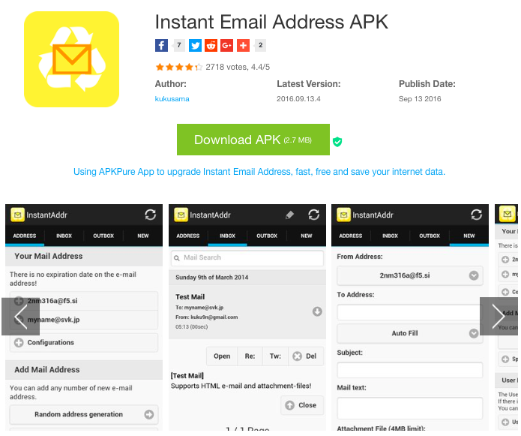 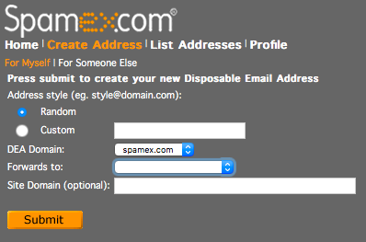

*Figure 1: Instant Email Address on the Play Store. Figure 2: Spamex User Interface.*

This project is different from the competition as it forces the linking of contacts with a unique email address supplied to only them. Doing this will afford the project the potential to provide some interesting features. As a side note, spam filtering and features like Outlooks’ Clutter and inbox ruling could be considered competition for this project. However, there is no reason why similar features could not be incorporated into a future release of this product, in turn, making it more effective.

**Project Life-Cycle .**

Due to the current lack of technical knowledge with regards to email hosting this project carries a certain level of risk. To reduce this risk and help ensure that a working MVP is produced for the projects demonstration, an incremental software process will be used during development. This will reduce time on spent planning features that may not be implemented within the projects initial time-scale. The spiral methodology was considered and it was therefore decided to prioritise the most risky and essential features. However, a custom life-cycle has been chosen to develop this project *(Figure 3)*. It is similar to scrum, however, it has been created for individual project development.

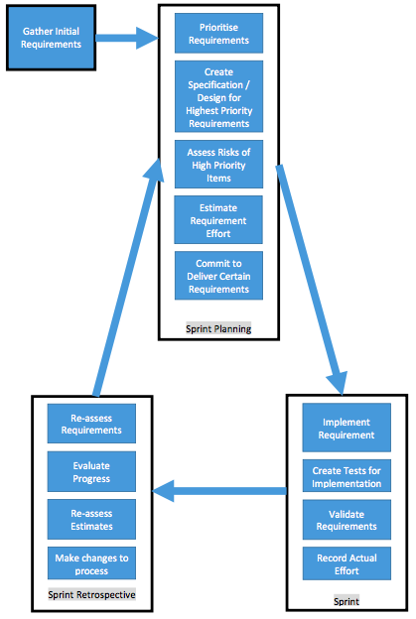

*Figure 3: Project Life-Cycle.*

**Project Plan .**

This project is going to consist of three or more sprints. Each sprint will last four weeks and will consist of no less than 30 hours of work. The layout of which is shown in figures 3 and 4.

**Prioritising Requirements:**

Items of work needed to create the MVP will be completed first. Then surveys will be used to gather user delight and annoyance factors towards a feature being delivered and not being delivered respectively. A calculation will then use this information along with the developer effort estimates to assess the priority of the remaining features. This calculation will place more value on the delight and effort factors than the annoyance factor.

**Estimates:**

Estimates will be made using story points in a Fibonacci sequence in the sprint planning phase. During development estimates may be changed by the developer but a reason will need to be recorded reflecting why. Actual time will be recorded during development and the average amount of time per story point will be recorded at the end of each sprint. This should help the developer decide how much to commit to during the subsequent sprint.

**Work Item:**

A work item will be created for each requirement being brought into the sprint and backlog. Each work item will outline a more detailed description of the requirement, testing criteria and relevant system and user interface designs. The item will be moved through a Kanban board until it is designated as done. The work item may be altered by the developer at any time as long as the original is recorded with a reason.

At the end of the sprint the developer will make a list of things that went well, went poorly and thinks that could be changed. This will be discussed with the project mentor who in turn will help decide if a change will be implemented or not. The developer may add new requirements to the project. However, these new requirements will need to be of high priority to be brought into the sprint.

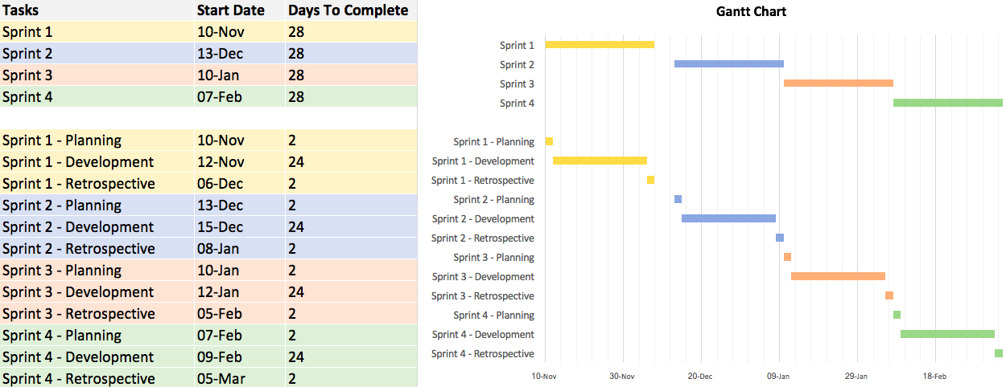

*Figure 4: Gantt Chart*

**References .**

Office of Information Technology. (2007)

*Undergraduate Email System Requirements*

Available: <http://www.oit.ucsb.edu/committees/CNC-EMail/requirements.asp>

Last accessed The 22nd of October 2016

PSDgraphics, (2013)

*male silhouette (Cover page image)*

Available: <http://www.psdgraphics.com/file/male-silhouette.jpg>

Last accessed The 25th of October 2016

Radicati Group, Inc. (2015)

*Email Statistics Report, 2015-2019*

Page: 3

Available: <http://www.radicati.com/wp/wp-content/uploads/2015/02/Email-Statistics-Report-2015-2019-Executive-Summary.pdf>

Last accessed 29th Sep 2016

Radicati Group, Inc, (2016)

*Email Statistics Report, 2016-2020*

Page: 2

Available: <http://www.radicati.com/wp/wp-content/uploads/2016/01/Email_Statistics_Report_2016-2020_Executive_Summary.pdf>

Last accessed 25th Oct 2016